Questions and Exercises to work out and turn in:

Grading Guidelines:

Exceptionally for this homework, you will not have to justify your answers. Just be neat and provide complete answers.

============= The following rubric does not apply to this homework.

A right answer will get full credit when:

1. It is right (worth 25%)
2. It is right **AND** neatly presented making it easy and pleasant to read. (worth an **extra** 15%)
3. There is an **obvious and clear link** between 1) the information provided in the exercise and in class and 2) the final answer. A clear link is built by properly writing, justifying, and documenting an answer (worth an **extra** 60%).
4. Calculation mistakes will be minimally penalized (2 to 5% of full credit) while errors on units will be more heavily penalized.

**Late Submission** : as specified in the syllabus. Days counting starts one minute after the deadline.

**Check Your Submission:**  after submitting, download your submission to check whether it is the right version and it is complete.

You are welcome/encouraged to discuss exercises with other students or the instructor. But, ultimately, **personal** writing is expected.

* USE THIS FILE AS THE STARTING DOCUMENT YOU WILL TURN IN. **KEEP IN THE QUESTIONS** AND INSERT YOUR ANSWERS.
* IF USING HAND WRITING (STRONGLY DISCOURAGED), REWRITE THE QUESTIONS.
* FAILING TO FOLLOW TURN IN DIRECTIONS /GUIDELINES WILL COST A 30% PENALTY.

Objectives of this assignment:

* to implement programs that communicate over the Internet
* to implement such applications using socket programming.
* Understand the relashionship *IP addresses - Host Names*

What you need to do:

Answer the questions and/or solve the exercises described below.

Exercise 1 (100 points)

The objective of this exercise is to get you familiar with the types used in Java to handle IP addresses.

Consider the program ***InetAddressExample.java[1]*** provided with this homework:

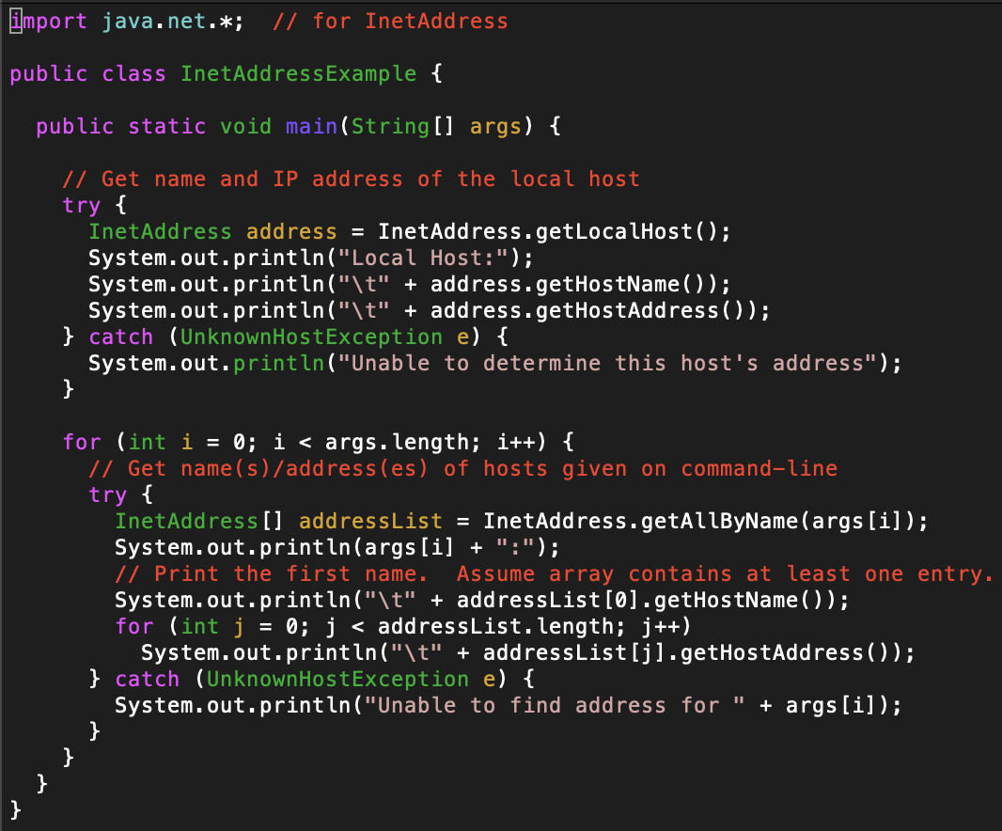

a) (20 points) Download, read, examine, compile, and run this program to understand this program. Execute the following commands and **provide the screenshots** of the responses:

1) (5 points) java InetAddressExample

2) (15 points) java InetAddressExample www.harvard.edu www.yale.edu

b) (80 points) Modify this program to create a program named MyInetAddressExample.java to perform the following tasks:

1) Prompt the user to enter a hostname (e.g., www.auburn.edu)

2) Display the IP addresses in binary, binary dotted-quad, and decimal dotted-quad formats. We are interested only in IPv4 addresses (32 bit IP address). For example, if the user enters the hostname www.auburn.edu, then your program must display:

- (25 points) binary format : 10000011110011001000101010101010

- (25 points) binary dotted-quad format : 10000011.11001100.10001010.10101010

- (25 points) decimal dotted-quad format : 131.204.138.170

3) (5 points) Provide a screenshot of an execution of your program.

**What you need to turn in**:

* Electronic copy of this file (including your answers) (standalone) and the program source MyInetAddressExample.java (standalone) Submit this file as a Microsoft Word or PDF file.
* Recall that answers must be well written, documented, justified, and presented to get full credit.
* How this assignment will be graded: (**No need to justify answers for this homework assignment**)
* A right answer will get full credit when:
* It is right (worth 25%)
* It is right AND neatly presented making it easy and pleasant to read. (worth 15%)
* There is an obvious and clear link between 1) the information provided in the exercise and in class and 2) the final answer. A clear link is built by properly writing, justifying, and documenting an answer (worth 60%).
* Calculation mistakes will be minimally penalized (2 to 5% of full credit) while errors on units will be more heavily penalized.
* You are welcome/encouraged to discuss exercises with other students or the instructor. But, ultimately, personal writing is expected.

1. This file is in Instructional Resources in the folder Simple examples from reference book.